AIWEST-SENDAI 2019 - Sharing Tohoku-Aceh experience, knowledge and culture

Organizer: IRIDeS
Tohoku University

Co-Organizer: TDMRC
Syiah Kuala University
E-mail: aiwest2019@irides.tohoku.ac.jp

Abstract. AIWEST-DR was first launched in 2005 as part of Syiah Kuala University’s contribution to ensure the transmission of the experiences, lessons and research drawn from the 2004 Sumatra Earthquake across the regions and countries at risk of a tsunami. The members of TDMRC (Tsunami and Disaster Mitigation Research Center) have taken the step to globalize their conference by offering Tohoku University the opportunity to organize AIWEST@SENDAI 2019. This year’s theme will be “Raising Tsunami Awareness, Reducing Tsunami Risk: Sharing Tohoku-Aceh Experience, Knowledge and Culture.” We wish to celebrate the long partnership between Tohoku University (IRIDeS- International Research Institute of Disaster Science) and Syiah Kuala University (TDMRC-Tsunami and Disaster Mitigation Research Center). It will also be an opportunity to draw comparative studies between the 2004 Sumatra Earthquake and Tsunami and the 2011 Great East Japan Earthquake. Last but not least, it will be an opportunity to further our application of the UN Sendai Framework for Disaster Risk Reduction (SFDRR) endorsed in Sendai in March 2015. To reach these goals, we invite all researchers, practitioners and policymakers to contribute to this long conversation between Indonesia, Japan and beyond, to raise tsunami awareness and develop the culture of risk prevention. This event will take place in coordination with the World Bosai Forum, November 9-12, and the World Tsunami Museum Conference, November 8, 2019.

Call for Abstracts
Prospective presenters in AIWEST-DR are invited to submit their abstracts that consist of 250 words or less with title and affiliation and five keywords following the abstract. The papers to be presented in this conference must have not been presented, accepted for publication or published elsewhere. The abstract should be submitted before July 1, 2019 and the full paper should be sent before October 1, 2019. The abstract should explain the brief background of the paper, objectives, methods, and important findings. All submitted full papers will be subjected to a review process and those successful invited to be published as part of the conference proceedings (Scopus-indexed IOP Proceeding).

Important Dates

Table 1. Venue: IRIDeS, Sendai, Japan
Deadline for Abstract Submission | July 15, 2019
Abstract Acceptance | August 1, 2019
Full Paper Submission | October 1, 2019
Registration Presenters | October 1, 2019
Conference dates | November 7-8 (AM), 2019
Field trip (half day) | November 7 (PM), 2019

Scope of the AIWEST-DR 2019
The scope of the AIWEST-DR are expected to cover the following topics (but are not limited):

  - Topcis
- Geohazards, Technology and Infrastructure;
- Disaster Culture and Knowledge
- Coastal City Resilience Towards Natural Hazard;
- Knowledge management for Disaster Risk Reduction;
- Disaster Risk Financing and Insurance;
- Human Security and Disaster Medicine;
- Policy Making for Sustainable Disaster Risk Reduction;
- Hydro-meteorological Hazards and Climate Changes;
- Tsunami Numerical Modeling and Its Applications;
- Resilient City Planning;
- Evacuation Planning and Training;
- Disaster Education;
- Emergency Handling and Psychological Dimension of Responses;
- ICT Application in Disaster Management;
- GIS and Remote Sensing for Disaster Management;
- Local and Indigenous Knowledge for Disaster Risk Reduction;
- Applied Geosciences for Disaster Risk Reduction;
- Effective Recovery, Rehabilitation and Reconstruction;
- Paleo-tsunami and Paleo-seismic studies;
- Disaster Management in Religious Perspective;
- Progress of SFDRR implementation. Welcome to Sendai and to AIWEST-DR 2019!

Acknowledgments
Syiah Kuala University and the Tsunami and Disaster Mitigation Research Center (TDMRC) Tohoku University and the International Research Institute of Disaster Science (IRIDeS)

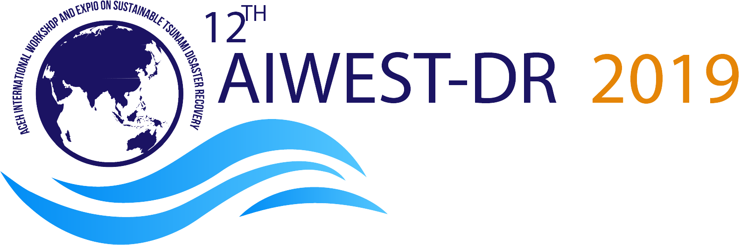

Figure 1. AIWEST-DR 2019 logo

Appendix
You can use the source of this document as the template for your abstract and full paper.

References
- Reference 1 goes here
- Reference 2 goes here

